 | PACIFIC INDIA VENTURE  Tapkir Plaza, Nigdi, PCMC, Pune 411044  Mo.9527352858, Email pacificindis.pcpcpune@gmail.com | . . श्री स्वामी समर्थ . .  . QUOTATION .  GSTN : 27AAKPF1080D1Z4  STATE : Maharashtra CODE:27
Manufacturing & Supply of SPM, Precision Tools, Die & Components

To | M/s PREMIER SEALS (India) Pvt. Ltd.  20/8, D-1 Block, MIDC, Chinchwad, Pune.  Maharashtra - 411019  GSTIN/UIN : 27AABCP6517B1ZQ | SR. No. : PI - 1079  DATE : 18/02/2026  REF NO. : __________  VALID FOR : 15 DAYS
For any queries regarding the quotation, feel free to contact the concerned person.

QUOTATION – JOB WORK

Sr. No. | Particular |  | Qty. | Unit Price | Total Price (R)
1. | PS_3461-24 PLUNGER PIN  (Complete set as per model provided, Precision finished & work suitable) |  | 16 Set | 515.00 | 8240.00
 | Job Material – As required

Note –

Grand Total (INR): 82400/-
(Rupees Eight Thousand Two Hundred Forty Only)

Terms & Conditions
- E. & O.E.
- Delivery Period: As mention on PO from the order date and advance.
- Payment Terms: As mutually agreed and finalized with the company.
- Taxes & Duties: GST @ 18% extra as applicable.
- Freight: Charged extra at actuals.
We look forward to your valuable order and assure you of our best quality and timely service.  for PACIFIC India Venture    Authorized Signature | 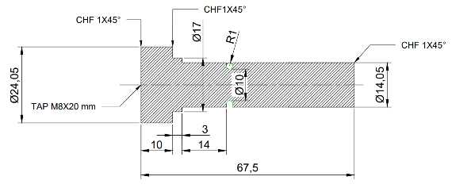

We thank you for your valuable enquiry and trust this quotation subject to the Terms and conditions given above will find your approval. Your order will receive our prompt and careful attention.

CONTACT PERSON NAME | CALL | EMAIL | DELEVERY
N. CHANDRA | 9527352858 | pacificindis.pcpcpune@gmail.com

QUOTATION – MATERIAL AND PROESS DETAILS

With reference to QUOTATION No. ___________ following details

Technical Details
Sr. No. | Particular | Material | Detaik | Cost | Remarks
1 | Material Cost | P20 | Size 120 x 100 x 90 mm | 3000
2 | Machining Cost
3 | Special Machining
4 | Treatment
5 | BOM
6 | Miscellaneous Overheads
7 | Assembly
8 | Profit
9

QUOTATION - TECHINICAL PROCESS DETAILS

With reference to QUOTATION No. ___________ following details

Technical Details
Sr. No. | Part Name | Material | Process | Cost | Remarks
1
2
3
4
5

